Safeguarding Futures: Rethinking Preventative Approaches to Protect Minors from Recruitment and Use in Colombia

María Paula Espejo, Yadira Lizama-Mué, and Juan Luis Suárez

1. **Introduction**

Reports on children in armed conflicts highlight obstacles to prevention and protection efforts while emphasizing the need to recognize child soldiers as more than just victims. After the Machel Report,[1] numerous legal initiatives[2] were undertaken to safeguard children. These took the form of frameworks,[3] conventions,[4] protocols,[5] guidelines,[6] principles,[7] and various other documents. Scholarly works have also explored these phenomena from various perspectives. Authors like Drumbl emphasize the challenges of reintegrating child soldiers into their communities, underscore their agency as active citizens,[8] and point out the various forms that illicit use of children can take during periods of political violence. All of these dynamics inhibit preventative efforts.

Understanding child soldiers presents two key challenges. Firstly, there is a misconception regarding child soldiers as young children carrying large weapons and serving as frontline combatants in African countries. Most child soldiers are adolescents between 15 and 17 years old, only 40% of them are of African origin, and many have roles beyond combat duties.[9] Additionally, documenting the prevalence of child soldiers faces significant obstacles like underreporting and competition among agencies and non-governmental organizations (NGOs) working in the field who do not share their data.[10] Consequently, policymakers’ understanding of the root causes of conflict -- such as motivations for joining armed groups and the socio-economic context that drives youth toward violence[11] -- including post-conflict involvement in illegal armed groups or gangs, remains insufficient.  This chapter thereby links to research about trafficked children and criminalized children as expertly dealt with by Silvia Scarpa in this volume.

Post-conflict scenarios bring forth fresh challenges as pernicious new groups and actors emerge. Some of these entities are sustained by illegal economies.[12] New groups exhibit high adaptability and dissuasion strategies which keep them from direct confrontation with the National Army and Police forces and thereby render them difficult to combat. In fact, gangs and small armed groups are often where minors begin their criminal journeys, especially minors more vulnerable to structural violence. Furthermore, this chapter explores the inability of peace agreements to prevent youth violence despite including child recruitment in negotiation agendas, notably, due to the shift from armed violence to criminal violence and the multiplication of new emerging groups that aim to navigate within the thin line between being an armed and an organized crime group.

Furthermore, boys aged between 14 and 17 from low-income households face stigma and discrimination by other fellow citizens and some police officers,[13] creating a binary perception of this group of adolescents where they are dangerous, poor, or helpless. Such binary categorizations impede the understanding of the big picture and exacerbate the gap between institutions and the very population they aim to safeguard.[14] A need consequently arises for context-specific prevention strategies with an intersectional approach that includes age, socioeconomic status and gender, at the very least.

This chapter analyses the use of minors and the accompanying challenges for the prevention of child recruitment and use in post-conflict scenarios. Colombia will be our case study as it meets key characteristics addressed above, namely, the presence of atomized groups involved in illegal economies (including drug trafficking, arms, human trafficking and illegal mining)[15] within the context of a transitional period introduced by the Havana negotiations. Our entry ramp is the literature on child recruitment and its challenges in transitional justice periods already identified in the secondary literature,[16] the Colombian case, and data from the Ombudsperson’s Office in Colombia.

Part 2 of this chapter examines the sources of violence in the current Colombian context. Part 2 shows how the country's Early Warning System has collected data intending to prevent systemic human rights violations. In Part 3, using Natural Language Processing techniques, this chapter analyses a dataset comprising over 1753 documents issued by the Colombian Ombudsperson Office, including over 900 early warnings, with specific focus on the geographic distribution of illegal armed actors and the strategies they employ for the recruitment and utilization of minors. Part 3 comprises the heart of this chapter and contains several subsections, and is buttressed with tables and figures. Part 4 identifies and proposes effective preventive mechanisms to the problem of the recruitment and use of children in armed conflicts. Part 5 concludes.

1. **Background to the Violence and Responses Thereto**
2. ***The Colombian armed conflict***

The conflict in Colombia follows a center-periphery logic that has given rise to two contrasting experiences and divergent perspectives concerning the country’s needs.[17] Despite ongoing violence, monitoring the conflict’s evolution and dynamics and preventing the recruitment and use of minors by armed groups remain imperative.[18] Efforts throughout the conflict have been persistent yet unsuccessful. As conflict and violence have transformed over the years, new challenges have arisen and the justice system has not caught up with the mutating scenario to effectively protect minors.

Colombia’s violent history is characterized by a dozen peace negotiations and three central transitional processes involving various armed groups resulting in different documents, agreements, or national legislation and policies.[19]

The first major transitional period was prompted by demobilization of several groups following the 1991 Constitution such as M-19, Movimiento Quintín Lame (MQL), Ejército Popular de Liberación (EPL), and Partido Revolucionario de Los Trabajadores (PRT). A second transitional period began after the San José de Ralito I and II accords between Autodefensas Unidas de Colombia (AUC) paramilitaries and the Alvaro Uribe Velez administration. This lead to the enactment of Law 975, also known as Justice and Peace. Law 975 faced significant criticism from national and international human rights organizations due to its perceived inadequate contribution to justice, truth, reparation, and non-recurrence guarantees for victims and society at large.[20] Debates have surfaced surrounding the actual demobilization of the AUC, as observers consider the AUC a ‘narco-paramilitary’ group unwilling to relinquish drug trafficking profits while retaining close ties to drug lords and ‘parapolitics’, namely, politicians financed by drug traffickers from different political parties and different regions in the country who facilitated strategic rural corridors for drug-trafficking.[21] The third tranche involves implementation of the peace accord signed with the Fuerzas Armadas Revolucionarias de Colombia (FARC) guerrillas on 24 November 2016 at the Teatro Colón in Bogota after the Havana negotiations.[22] These negotiations were conducted between 2012 and 2016 in Havana, Cuba. This peace accord has received international recognition for its inclusion of gender, ethnic, and territorial perspectives, adhering to the highest standards of international human rights law and transitional justice.[23] However, challenges in Colombia’s political climate and institutional capacity to implement the agreements have hindered a glide-path to peace. New factions of the FARC have emerged, along with antecedent armed groups that remain active such as the guerrilla Ejército de Liberación Nacional (ELN), the Autodefensas Gaitanistas de Colombia (AGC), and the Águilas Negras. Additionally, drug-trafficking organizations operate in gray zones,[24] further complicating efforts to protect civilians from systematic human rights violations in rural and urban areas.[25]

Overall, the Colombian case has been classified as a non-international, protracted armed conflict due to its longevity, intractability, mutability, and widespread violations of international humanitarian law.[26] The conflict’s root causes include land disputes, limited political participation and representation, and deep sectarianism fueled by political leaders and traditional parties. Colombia has a backdrop of poverty, inadequate access to basic services, and a complex political culture permeated by illegal groups and their interests that increase further the generalized lack of trust in institutions, resulting in prevailing inequality, particularly affecting vulnerable populations such as peasants, Afro-Colombians, and indigenous communities.[27] These populations are predominantly found in peripheral urban and remote rural areas characterized by high poverty rates and limited state presence.[28] The conflict has led to devastating consequences, with approximately nine million victims including 210,000 forcibly disappeared individuals, over 750,000 displaced persons, and numerous massacres across 62% of municipalities. Child recruitment, a typically underreported phenomenon, has resulted in at least 16,238 documented cases between 1990 and 2017.[29]

Illegal economies --particularly drug trafficking -- along with socio-economic inequality have consistently played crucial roles in perpetuating cycles of violence. These illegal economies pull and push youth towards illegal groups.[30] It is important to note that all armed groups, regardless of their ideological orientation or tactics, have used minors in hostilities. The actors responsible for violence throughout the conflict include guerrillas, paramilitaries, drug cartels/traffickers, criminal gangs, and the Colombian army.[31]

1. ***Ombudsperson’s Office – role, efforts and timeframe***

The Ombudsperson’s Office is responsible for monitoring Colombia’s human rights guarantees. It operates through fifteen delegates and four national directorates. It has regional offices and dedicated teams for each area. In 2001, the Early Warning System (SAT,- Sistema de Alertas Tempranas in Spanish) was established amidst Colombia’s intense violence. The system issues early warnings[32] on human rights and international humanitarian law violations concerning the armed conflict.

Since 2017, the 2124 Decree following the peace accord mandated SAT to alert about impediments to peace agreement implementation. Follow-up reports assess institutional responses to warnings and their efficacy in preventing or mitigating risks. SAT’s warnings hold value for international organizations, human rights entities, and social leaders. However, the Ombudsperson’s recommendations lack binding force. They operate as a moral authority without legal or administrative power to hold institutions accountable for action or inaction. Despite the preventive spirit of the warning documents, most of them include recent, current or ongoing human rights violations. Nonetheless, data within the SAT documents is valuable due to the widespread presence of the team’s analysts across the country and their confidential engagement with communities which grants them privileged information.

In analyzing SAT documents, this chapter divides the covered period into four-time segments:

1. 2001-2005: Conflict - Justice and Peace Law

2. 2006-2011: Post-Demobilization of Paramilitary Groups

3. 2012-2016: Havana Peace Negotiations

4. 2017-2022: Post-Agreement Phase

These divisions help track changes in conflict dynamics, actors, and strategies tied to child recruitment and use. Cardeli et al. utilize Bronfenbrenner’s ecological systems theory to explore the personal, social, and cultural factors that contribute to a child’s involvement in violent groups.[33] They examine the interactions among the individual child, microsystem (family, peers, and school), mesosystem (interactions within the microsystem), exosystem (government, politics, and social services), and macrosystem (culture and ideology) in the context of minors recruited by Central American gangs and terrorist organizations. Factors such as religion (predominantly Catholic/Christian), culture (machismo), socio-economic vulnerabilities, and public policy play a role in understanding children’s involvement in violence. The interactions among these systems provide insights into key elements, moments, and actors that can inform effective strategies for preventing child recruitment and use.[34] We finds this a helpful frame for Colombia, as well.

To deepen the upcoming data analysis there are key aspects of the Colombian legislation worth mentioning. According to Colombia’s Civil Code, article 34: ‘The term *boy* or *girl* (children) refers to persons between 0-12 years of age, and *adolescent* to persons between 12 and 18 years of age’. In this chapter, we will use the terms and age groups suggested by the Civil Code. We interchangeably use the terms “adolescent” and “teenagers”. The term “minor” will refer to all those from 0 to 18 years of age, and any other age reference will be to those classified in adulthood (19 and older). Across the chapter, we will refer to age categories to add layers of information that will contribute to expanding the understanding of the different interactions among Bronfenbrenner’s theory that will inform our discussion, which is largely focused on adolescents rather than combatant children.

Another key policy for our analysis is the Permanent Directive No. 15 (2016) from the Ministry of Defense. This Directive classifies illegal groups into Organized Criminal Groups[35] and Organized Armed Groups[36] and focuses on transnational crime and not the internal armed conflict. This classification undermines the guarantees for protecting and redressing victims of systematic human rights violations, as it restricts the acknowledgment of individuals as victims based on the acknowledgment afforded to the perpetrator. Put differently, this directive prioritizes the recognition and categorization of illicit groups over the imperative to safeguard and ensure redress for victims, a principle that has significantly advanced within the legal framework of Colombia, exemplified by the Victims' Law of 2011. An illustration of this phenomenon is evident in the potential obstacles faced by victims associated with dissidents or spoilers of peace agreements—those who refrained from surrendering or actively sabotaged negotiations, demobilization efforts, and processes related to disarmament and reintegration (DDR)—in gaining inclusion within the Unique Registry of Victims, as they are classified merely as victims of common crime. Consequently, this situation adversely affects statistics concerning insecurity and common criminal activities in urban settings, thereby diminishing or negating the significance attributed to groups such as those discussed in this chapter, especially those addressed as Localized groups.

Consequently, we chose our own group categories for our analysis: guerrillas, paramilitaries, strongholds, FARC dissidents, and localized armed groups. Another available classification is the one suggested by the International Committee of the Red Cross (ICRC), but it fails to overcome our reservations concerning the Permanent Directive when it comes to victims’ guarantees.

1. **Data and Methodology**

The dataset from the Ombudsperson’s Office consists of 1753 documents, which can be categorized as follows:

·       Early Warnings (378) and Risk Reports (681) provide information on potential risks and threats in conflict-affected areas of the country. These also offer general recommendations to authorities for mitigating human rights violations.

·       Notes (558) and Follow-Up Reports (136) provide updated information on previously identified risks, evaluate the implementation of recommendations, identify new risks, and track the situation over time.

Out of the total 1753 documents, 1105 (63%) mention recruitment and use of children (NNAJ) with 796 (45%) specifically describing situations related to this issue. The acronym NNAJ is used in the Ombudsperson’s Office’s data to refer to minors under 18 years of age, children (boys and girls), adolescents, or young people (hereafter, when mentioning NNAJ we refer to any of these categories or all at once). Figure 1 illustrates the distribution of documents released from 2001 to 2022 and the occurrence of NNAJ terms therein. Notably, reports mentioning NNAJ recruitment and use were initially low from 2001 to 2008 but steadily increased thereafter to account for over 90% of the institution’s communications. The decrease observed from 2019 onwards does not necessarily indicate reduced risk but rather reflects limitations in report production due to the COVID-19 pandemic.

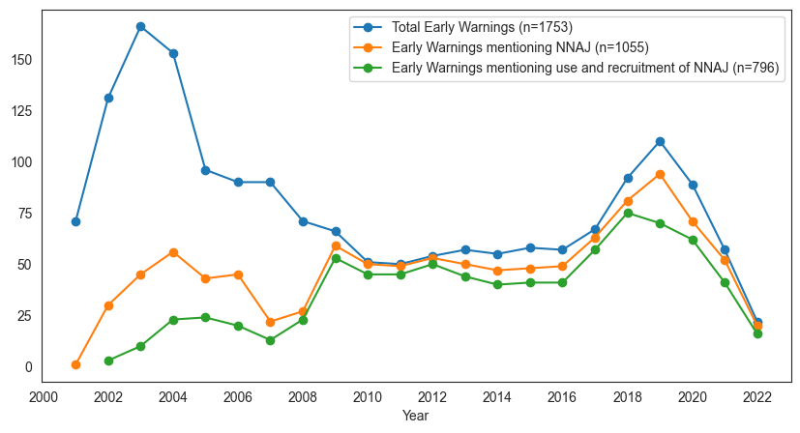

Figure 1. Annual distribution of documents released by the Ombudsperson’s Office

The three-steps methodology is based on the use of Natural Language Processing (NLD) to extract relevant data points from documents leveraging its potential applied in similar contexts.[37] This study applies NLP algorithms to uncover latent patterns of child recruitment and use in the Early Warning Reports released by SAT. This is achieved by identifying, collecting, and longitudinally analyzing information from reports, including actors involved, locations, risk factors, recruitment strategies, and recommendations for child protection. The research project adopts the data science pipeline developed by Lizama and Suárez,[38] which guides researchers through various stages from conceptualization to research communication.

To conduct a longitudinal analysis of child recruitment and use in Colombia using the Ombudsperson’s SAT, we extract the following information from each report: release year, Colombian departments mentioned in the warning, criminal organizations involved in recruiting children and national/territorial institutions addressing the problem (actors), and the actions described in the reports that entice or force children into illegal activities (recruitment strategies).

The 1753 PDF reports were converted into plain text using two Python libraries: 1) pyPDF, a toolkit that allows text and metadata extraction from PDF documents,[39] and 2) Tesseract-OCR for Optical Character Recognition on the images included in the reports.[40] Tables and images were transformed into paragraphs while retaining the original sentence structure. Five confidential documents were excluded from the analysis. Among the challenges to processing data, we found reports lack a predetermined format. Critical sections such as Antecedents, Description of the Risk Situation, or Recommendations are in unlikely orders, under different headings, or in different formats. Unlike structured data, no explicit coordinates point to required data attributes. Therefore, NLP methods (Named Entity Recognition, N-gram modelling, and Parts of Speech Tagging) were employed to extract data points by deciphering the language’s morphological, syntactical, and semantic layers.

To ensure quality and reliability, three steps were taken. First, a spell-checking Python library was used to minimize errors introduced in the conversion from PDF to plain text.[41] Non-matching terms were replaced with relevant suggestions. Second, entities with similar meanings were interchanged with a common term (e.g., replacing different variations of “FARC” with “FARC-EP”). The ultimate step involved lemmatization and stemming to reduce words to their base forms, enhancing context relevance in analytical models.

To extract required data points, our analytical approach employs two NLP subtasks: Named Entity Recognition (NER) and Semi-Supervised Key Phrase Extraction. NER involves recognizing entities placed in the text such as persons, organizations, locations, time expressions, quantities, and monetary values.[42] We utilize the NER model in Spacy, a state-of-the-art Python library optimized for NLP tasks.[43] This pre-trained model for the Spanish language performs accurately and efficiently, enabling the identification of dates, organizations involved in child recruitment and use, and targeted Colombian departments.[44] Key Phrase Extraction focused on identifying recruitment and use strategies. It involved extracting significant phrases from segments/sentences where NNAJ is mentioned alongside recruitment and use. An intermediary step involved the identification of key phrases aligned with strategies, followed by an automatic approach for the remaining segments. A multimodal network incorporating actors, departments, and strategies was built to extract information on key nodes and their relationships during different periods of the Colombian conflict analyzed in this study.

**RESULTS**

1. ***The Actors Across Time***

Various actors --guerrillas, paramilitaries, strongholds, dissidents, and localized armed groups -- employ different strategies for using and recruiting minors. Historical and geographical context also influence the tactics of actors to recruit and use minors. This argument will be explored in more detail in forthcoming sections after presenting the different profiles of each group category.

Guerrillas are left-wing armed groups with communist ideologies which emerged during the Cold War. They aim to redistribute socio-economic and political power.[45] Guerrilla groups in Colombia, the FARC-EP, and the National Liberation Army (ELN) are prominent actors in this category. Debates have arisen regarding the validity of their social justice discourse in light of the casualties and victims resulting from their actions, particularly following the end of the Cold War and the events of 9/11.

Paramilitary groups, in contrast to guerrillas, formed a unified counter-insurgent front comprising various factions across Colombia. On the other hand, like guerrillas, they are characterized by large combatant groups and weaponry. The AUC, for example, united multiple auto-defence blocks around the country;[46] and financed their operations through contributions from targeted wealthy livestock farmers and participation in drug trafficking.[47] Collaboration between paramilitaries and the Colombian Army has sparked debates and investigations due to the commission of grave violations of international humanitarian law.[48]

The Strongholds category encompasses armed groups that emerged after the Justice & Peace process in 2005, such as Los Rastrojos, Águilas Negras, Gaitanistas Self-Defense Forces of Colombia, Los Urabeños, and The Gulf Clan. These groups primarily focus on economic control, notably in drug trafficking and other illicit activities. They often establish close relationships with political families and entrepreneurs at local and regional levels. They exert influence on political outcomes through campaign financing, vote buying, and imposing codes of conduct on the civilian population, in a fashion similar to paramilitaries and guerrillas during the late 20th and early 21st centuries.[49] Strongholds, as paramilitaries, rarely confront the Colombian Army, but are distinguishable because of their operational organization. We chose Strongholds to name this conglomerate of groups to distant our analysis from the Colombian institutional jargon, as these groups have been labeled as neo-paramilitaries, post-demobilized AUC groups, and Bacrim at their earlier stages (Criminal Bands). All labels bear a political charge that vindicates them, or not, as actors part of the Colombian conflict and, in consequence, have effects on their victims’ rights.

FARC Dissidents comprise a group of small factions that emerged after the Havana Accord between the guerrillas and the Colombian government. This category includes peace accord spoilers and rearmed combatants. There are over 30 new fronts of dissidents across the country that are either independent or under the leadership of Ivan Márquez, Gentil Duarte, or Comando Coordinador de Occidente (CCO). The power struggle between these dissident groups affects rural areas, such as southern municipalities in Tolima, Cauca, and Caquetá, with the civilian population caught in the middle as various factions claim legitimacy as successors to FARC.

The final category encompasses Localized Armed Groups, which operate within smaller geographical remits and focus on controlling urban-level illegal economies such as drug trade and human trafficking. Actors in this category include La Constru, Los Paisas, La Cordillera, La Terraza, La Oficina De Envigado, and other organized crime groups. These groups maintain links with Strongholds groups and international crime organizations such as Mexican cartels. To avoid direct confrontation with law enforcement, their members adopt civilian clothing which makes it difficult to distinguish them as combatants or members of specific groups. This category presents the most complexity, as it exists in a gray area between illegal armed groups within the armed conflict and international organized crime.

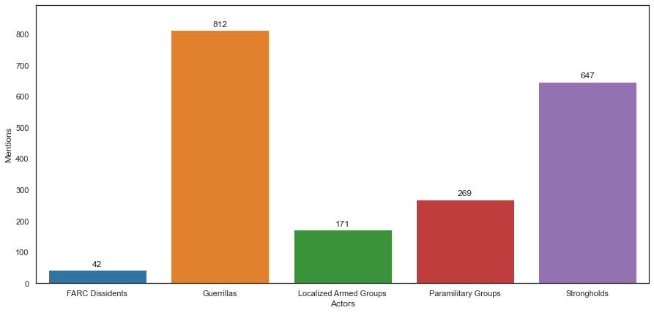Figure 2. Number of mentions of the conflict actors in the context of recruitment and use of NNAJ.

Figure 2 illustrates the distribution of conflict actor references in the Ombudsman’s Office documents from 2001 to 2022. As the conflict evolved, new categories emerged due to group demobilization, mutation, and the formation of new alliances, such as the emergence of FARC Dissidents after the 2016 Peace Agreement. The percentages of mentions in the Early Warning reports are as follows: Guerrillas (42%), Strongholds (33%), Paramilitary groups (14%), Localized groups (9%), and FARC dissidents (2%). This distribution reflects the transformation of the Colombian armed conflict and the adaptive strategies of illegal groups in response to events in the country’s recent history. During transitions governments are urged to show favourable results. Accordingly, the political cost of acknowledging the emergence of new groups can be taken as a lack of state power and control. In consequence, Police, Army and regional administrations systematically deny and challenge the affirmations of warning documents from SAT stating the presence of illegal armed groups within their territories. Hence, when victims approach institutions they face challenges to ensure their protection, reparation, and safety.

Figures 3 and 4 illustrate the changing prominence of group categories over time. Localized groups are noteworthy due to their limited geographical reach and collaboration with Strongholds groups. While localized groups have remained consistently active, other categories have experienced varying levels of decline as shown in Figure 4. Notably, only few instances arise where all groups simultaneously decrease their activity, other than the exceptional case of 2020 attributed to challenges during the COVID-19 pandemic. Each category encompasses multiple groups that emerged in different contexts, meeting specific criteria based on their interests and tactics. These groups employ diverse mechanisms to sustain their operations, including collaboration and merging. Figures 3 and 4 provide empirical evidence of the lifespan of each category, considering negotiations, peace accords, and implementation stages that support our four-period selection.

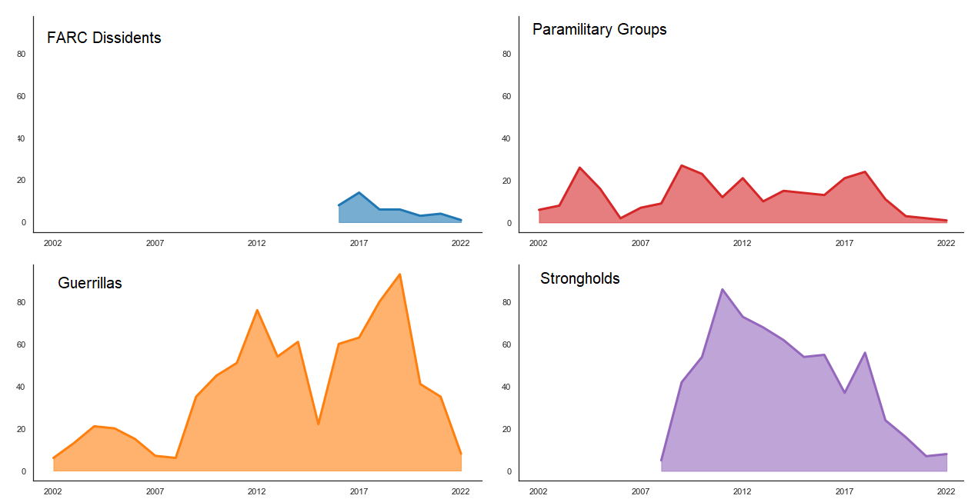

Figure 3. References to Actors of the Conflict in the documents (Part1)

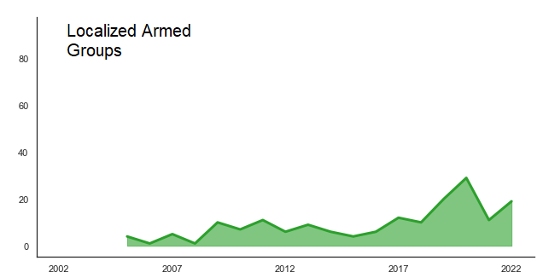

Figure 4. References to Actors of the Conflict in the documents (Part2)

1. ***Recruitment and use across the territory***

The recruitment and use of minors has spread across various regions in Colombia, as depicted in Figure 5, which illustrates the municipalities mentioned in reports indicating detected risks. The node size reflects the number of related documents from the Ombudsperson’s Office. Despite the office’s focus on preventing international humanitarian law violations, the data reveals an ongoing and persistent recruitment issue unaffected by the provided warnings. While the expansion of areas mapped with illegal group’s presence can be a partial result of the increase of territory covered by the SAT’s team, recruitment remains prevalent throughout the conflict and transitional periods.

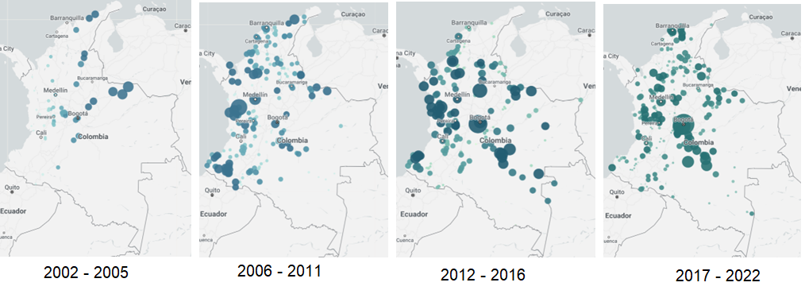

Figure 5. Geographic distribution of Early Warnings mentioning recruitment and use of NNAJ (Periods)

Historically, the peripheral regions have endured most of the armed conflict in Colombia. Peripheral regions experience both direct and structural violence. However, Figure 6 demonstrates that armed groups have increasingly utilized minors in populated areas, especially in the central regions, where cities are situated. The urban expansion of child recruitment suggests the diversification of groups and/or changes in recruitment strategies. Therefore, it was crucial for us to investigate whether the interests and tactics of these groups have shifted following the power redistribution resulting from FARC’s demobilization process and the territorial disputes and influences among Strongholds, Dissidents, and Localized groups that emerged in the wake of the implementation of the peace process.

Despite a decrease in the number of released documents during the pandemic, the post-conflict periods 2006-2011 and 2017-2022 (see Figure 5) demonstrate an escalation in the recruitment and use of minors. The loss of manpower, reconfigurations resulting from DDR processes, and the emergence of smaller groups further increase the risks faced by teenagers and young adults, particularly in impoverished and uncertain contexts like those exacerbated by COVID-19. The rise of Localized and Stronghold groups, also stemming from power reconfigurations following peace agreements, aligns with the fragmentation of child use phenomena nationwide and the broader Latin American trend during periods of transition to gang violence.

The geographic distribution of groups across Colombia, as presented in Figure 6, demonstrates that peace accords and negotiations, even when they acknowledge and condemn child recruitment and use, do not necessarily translate to a decrease in the practice. These findings indicate the complexity of the fights that ensnare children as well as the difficulty in ending such fights. Figure 6 illustrates the geographical distribution of Early Warnings related to child recruitment and use by various armed actors during the Colombian conflict and post-conflict phases. It is important to note that a single warning document may mention multiple groups, so the size of the nodes provides a better understanding of the groups utilizing minors rather than the spatial coverage on the map.

The Paramilitary, Stronghold and Localized armed groups have a similar geographical distribution pattern with different node sizes that respond to the nature of their tactics and the scale of operations. These three maps support the claims of a transformation and adaptation of Paramilitary groups across the Colombian armed conflict and transitional justice processes, as well as a possible coexistence and collaboration between the remaining Strongholds and emerging Localized groups.

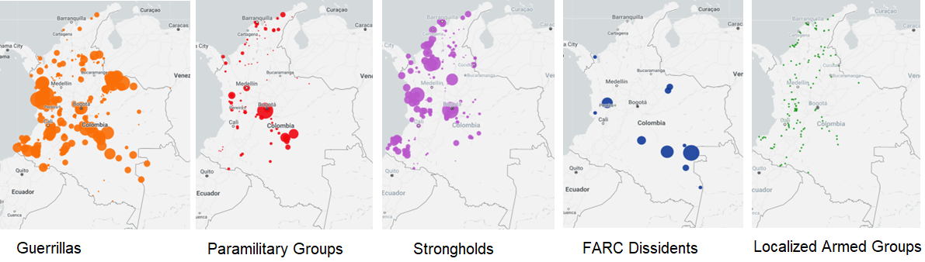

Figure 6. Geographic distribution of Early Warnings mentioning recruitment and use of NNAJ (Actors)

1. ***Strategies by Actor***

Methodologically, the identification of recruitment and use strategies for NNAJ involved a semi-automatic process. Relevant segments mentioning NNAJ, recruitment and use each were extracted. Keywords related to strategies were identified. A tagging system was developed and then refined on the Ombudsperson’s Office archive. Table 1 presents the 12 main strategies detected in the documents, the number of documents mentioning each, and some specific examples. Out of 796 documents on recruitment and use, 279 (35%) did not mention strategies. Two key elements are important for the analysis. First, the Colombian case presents several regional particularities, hence, even within the same group (especially for Guerrillas and Paramilitaries) their regional operations adapt to cultural and geographical contexts. Second, multiple strategies can coexist, this means that while in one place of the country girls are being recruited for non-combat activities, girl teenagers can be recruited as a vehicle to involve and recruit boy teenagers in another region. Additionally, these strategies adapt to the time and context the conflict is taking place and are the ones identified over two decades. In consequence, some are the mutation of others, for example, *recruitment family quota*, which was vastly implemented by guerrillas in the late 1900’s and beginning of the 00´s is not a common practice as *gifts, promises and handouts* are nowadays. It is important to highlight that strategies for recruitment adapt to territory, culture and time. Hence, the terms in Table 1 align with the transformation of the Colombian conflict and the emerging communication and status-quo norms like using technology to reach or attract younger generations.

 Table 1. Total of documents mentioning strategies of recruitment and use of children.

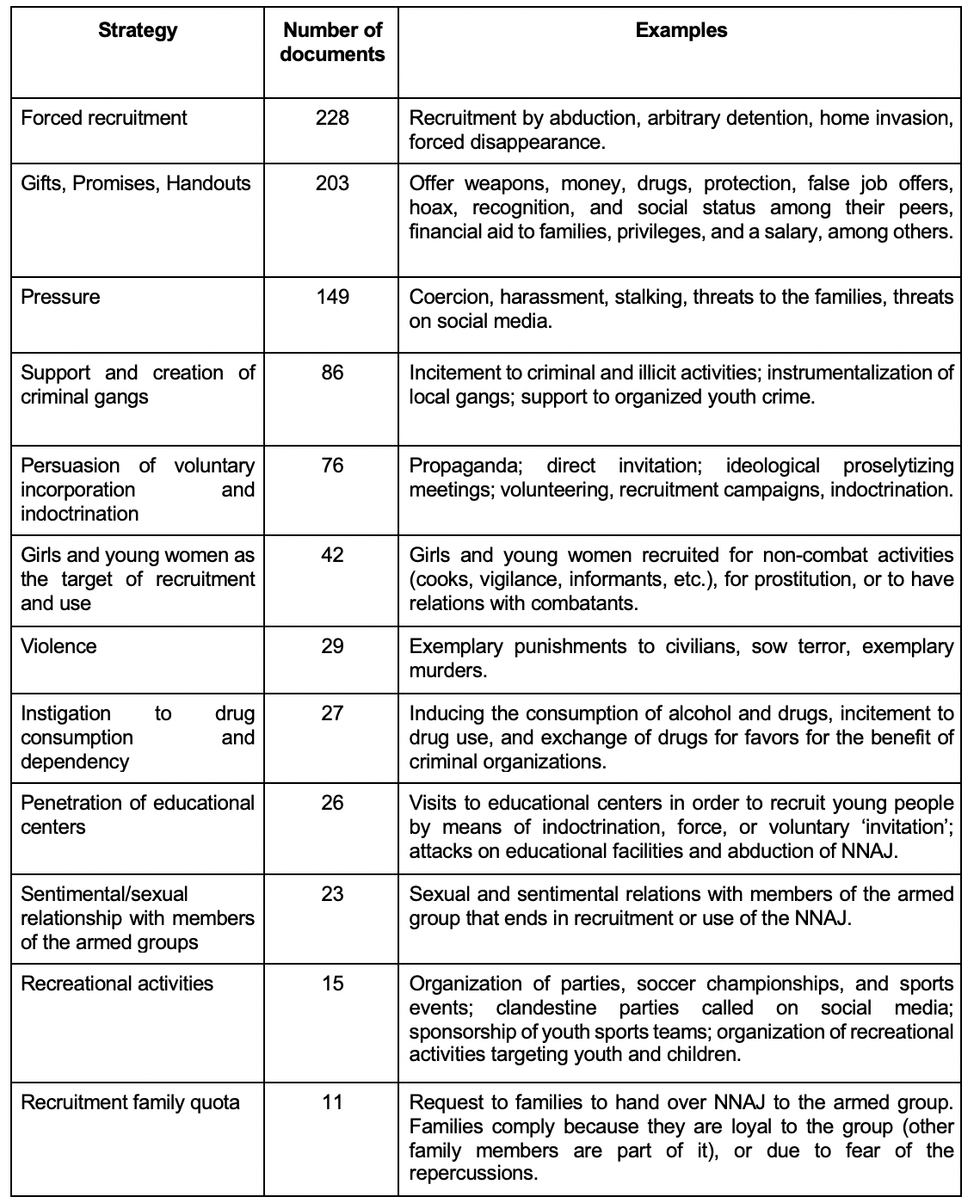

The strategies mentioned in Table 1 correspond to the ones employed by all group categories and across the four delimited periods. Networks were modelled to examine influential nodes and relationships between Departments, Actors, and Strategies. Nodes were linked if they co-occurred in reports. Four networks resulted from this analysis that correspond to the periods analysed along the chapter. Examination of the Colombian conflict and post-conflict confirmed the transformation and complexity of the phenomenon. Node types were color-coded: Departments (purple), Strategies (orange), and Actors (green). Node size indicates influence, with larger nodes having greater impact. Considering that the early years of SAT operations had limited presence across the country, as well as a more limited mandate, focus is placed on period-specific strategies rather than reported cases, actors, or locations. Paramilitaries were prominent prior to demobilization under Justice & Peace (2005), exhibiting diverse strategies (6 out of 12).

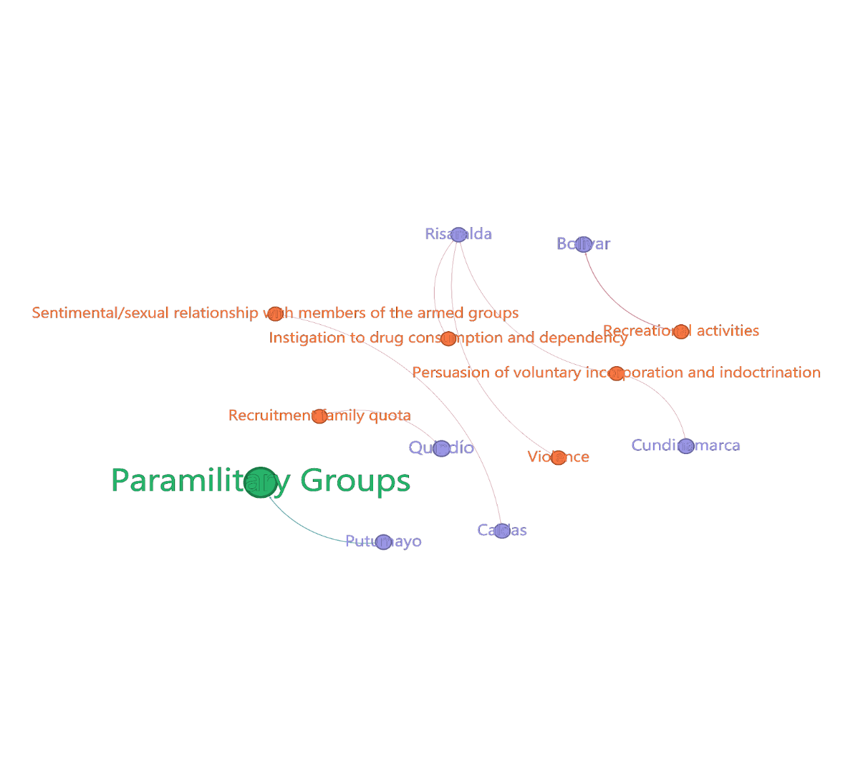

Figure 7 Network of Actors, Departments, and Strategies of Recruitment and Use (Justice & Peace 2001 - 2005)

In the period after Justice & Peace and before negotiations with FARC, warning documents revealed increased group and strategy diversity, including gender-based violence targeting girls, drug consumption induction, and discreet recruitment through recreational activities and persuasion. Some conflict zones, primarily peripheral rural areas (e.g., Amazon and Pacific regions), were highlighted. Guerrillas played a significant role in recruitment strategies but were not the sole actors, insofar as Paramilitaries, Strongholds, and Localized armed groups engaged in recruitment and use as well (Figure 8).

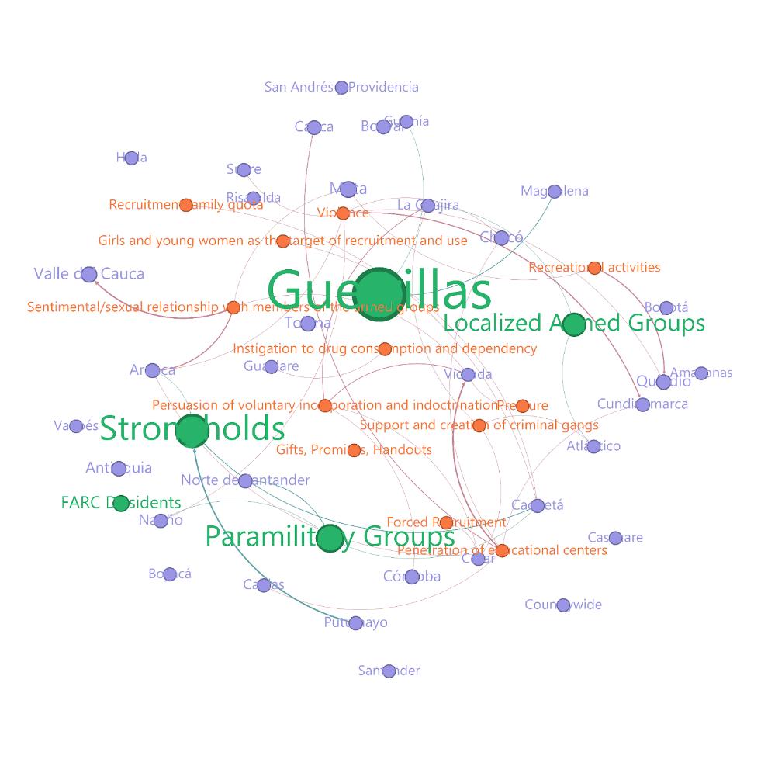

Figure 8 Network of Actors, Departments, and Strategies of Recruitment and Use (Conflict 2006 - 2011)

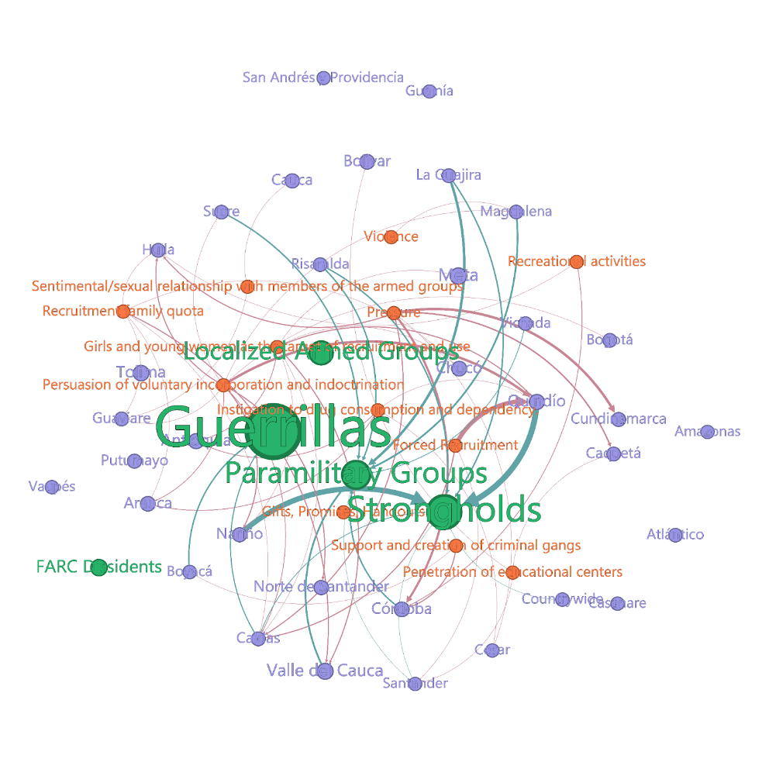

Figure 9 Network of Actors, Departments, and Strategies of Recruitment and Use (Peace Negotiations 2012 - 2016)

The network analysis (Figures 7 to 10) demonstrates the persistent nature of recruitment and child use across periods, territories, and group categories. Complexity increased with new strategies, new actors, and newly affected departments. The 2012-2016 period introduced strategies such as access to educational centers by means of violence, pressure, or attempts to indoctrination (Figure 9). Stronghold groups gained significance, driven by economic interests in illegal goods trafficking while maintaining child use to fulfill their goals. The avoidance by Stronghold groups of confrontation with legal forces may explain their presence in more departments and intermediate cities and capitals. Activity intensified in departments such as Risaralda, Santander, and Bogota (Figure 10), indicating an urbanization of the armed group dynamics and a shift toward use-related strategies (i.e., offering money and protection) rather than recruitment (i.e., recruitment as family quota).

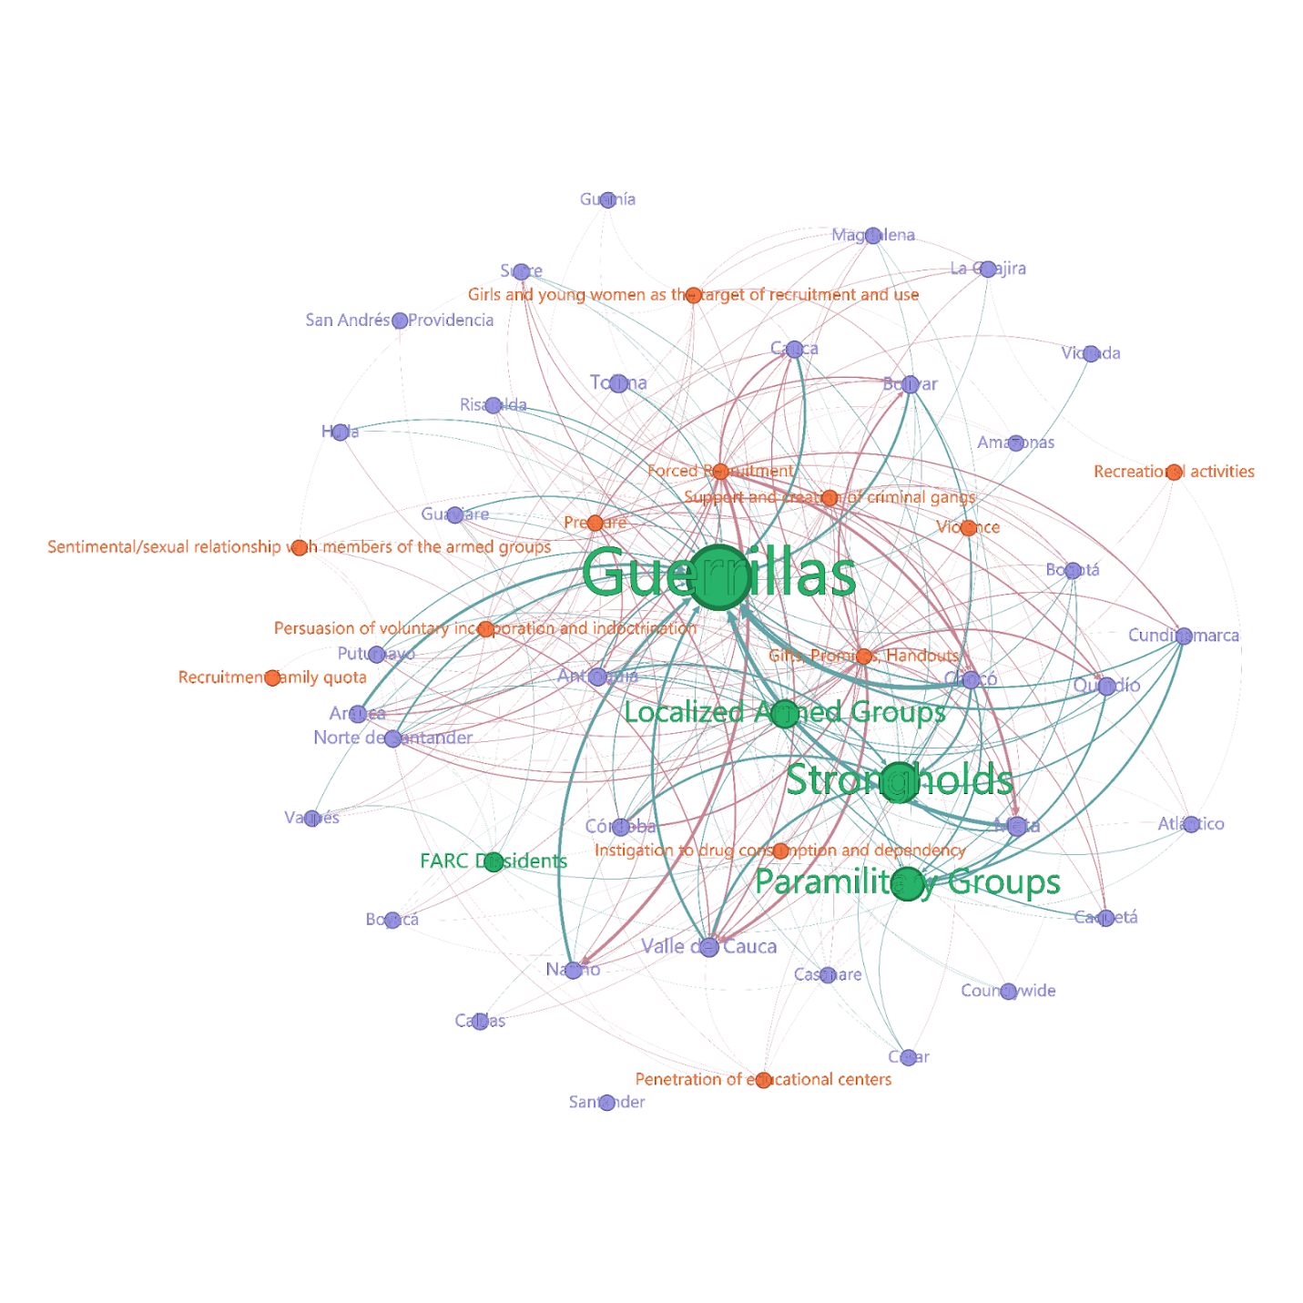

Figure 10 Network of Actors, Departments, and Strategies of Recruitment and Use (post-Agreement 2017 - 2022)

The network for the post-agreement period (Figure 10) includes the most nodes (n=51) and connections (m=251). Low-key strategies, such as “Gifts, Promises, Handouts” remained prevalent and became more manipulative and covert. Given high inequality rates in Colombia – the country has a 54.2 value on the Gini Index -- youth are susceptible to joining illegal armed groups[50] particularly Localized groups employing low-key strategies (Figure 10) that may pass as voluntary enrollment for some actors like Police and the Army. Minors starting as messengers or drug transporters often progress to combatant roles in their early adulthood or even during their late teenage years if they do not lose their lives before reaching adulthood. These dynamics enable groups to gain influence in urban areas and exert power over public policy decisions without physically controlling territory as guerrillas had done in the past century, but rather by exercising control socially and politically over the civil population. Several results of the Localized groups end up being catalogued as urban insecurity.

1. **Discussion**

Our discussion comprises two main sections: theoretical insights derived from analyzed data, challenges identified, recommended pathways for prevention strategies, and practical proposals for institutions and international agencies/donors. This offers a comprehensive perspective for researchers and stakeholders addressing prevention and non-recurrence in post-conflict settings.

The significance of classifying armed groups is crucial, particularly in discerning forces mobilized to combat threats to civil population security. However, we underscore the importance of considering the flip side: how the classification, or outdated scope, induces uncertainty for victims and public servants implementing policies without national consensus on victim identification and entitlements. For instance, in some cases, Colombia’s Victims’ Unit has only registered cases in the Unique Registry of Victims (RUV) if guerrillas or paramilitaries are responsible.[51] It is crucial to recognize human rights violations, analyze group interests, and acknowledge that victims' suffering occurs independently from the perpetrator. The type of perpetrator alone cannot determine the cognisability of injury. To put victims at the center and to find ways to improve guarantees for the enjoyment of human rights for all populations is vital and entails the moral responsibility to acknowledge the diverse needs to foster reconciliation in post-conflict realities.[52]

As discussed in the results section, localized groups coexist with strongholds and international criminal organizations which in turn contributes to increased insecurity and violence in Latin America. This phenomenon, observed in Colombia, shares comparative similarities with Central American gangs.[53] In Colombia, the blurred lines between armed groups, organized crime, and international crime underscore an acute need to reassess prevention, particularly focusing on teenagers to break violence cycles. This is a central theme of how children’s fights are not only armed fights.

To address the issue of younger generations becoming cannon fodder, prevention strategies must involve teenagers in the design and implementation process. Recognizing teenagers' agency, needs, and interests is paramount. Co-designing strategies with survivors, informed by academia and social organizations, can create genuinely engaging and feasible programs. We note similarities with work by Kirsten Fisher in northern Uganda and Myriam Denov in Rwanda (as published in this volume) when it comes to the need for inclusivity. We highlight the need for context-specific strategies that align with ecological systems.[54] Addressing the issue locally, tailoring to regional nuances, and adopting an intersectional approach can yield positive results.

What about insights gleaned from the Ombudsperson Office’s endeavours? Despite scrutinizing early warning data, our access to follow-up reports highlighted challenges in securing timely institutional responses preceding the forewarned scenarios. A notable deficiency in institutional communication, coordination, and collaboration arises. We advocate for the incorporation of measures to augment institutional processes and communication within prevention strategies. Another imperative lesson involves a paradigm shift in the methodological approach, signifying that the Ombudsperson’s Office can further benefit from its national presence by adopting more participatory methodologies such as the Everyday Peacebuilding Indicators.

Research has established that urban violence and insecurity significantly influences community perceptions of everyday peace indicators.[55] Post-conflict environments amplify the importance of daily life, prompting a reassessment of how peace manifests among various demographics, including minors. This shift in perspective and methodology necessitates collaboration with partners open to transformative approaches. International donors should carefully consider the projects they support so as to ensure alignment with community needs and realities. Additionally, addressing funding competition, which often inhibits information sharing between institutions and NGOs,[56] is crucial to effectively address targeted population needs and advance efforts to reduce child recruitment and use in conflict contexts.

1. **Conclusions**

In summary, the timeline, geographical distribution, and strategies in Early Warning documents highlight a transformation in how Colombia approaches post-conflict and intends to build a more sustainable peace, as the latest 2016 Peace Accord promotes. Moreover, the findings suggest the country also has the opportunity to grant more attention and resources to the criminal context that has systematically reshaped violence and impeded an effective transition to peace and non-recurrence guarantees. Groups have shifted from "hard" recruitment like abduction to "soft" tactics, promising protection, gifts, and salaries unlikely in legal contexts, particularly for vulnerable minors.

A notable factor is the discreet growth of Localized armed groups, coinciding with the introduction of "soft" recruitment strategies, that profit on structural violence conditions to avoid raising attention from the Public Force to reach youth in urban contexts and expand the presence and influence of illegal groups across the national territory as shown in Figure 10. These groups, dispersed across the country, lack substantial weaponry, blend with civilians to avoid confrontation, operate independently, and are motivated by socio-political influence. Collaboration with Strongholds groups amplifies the influence of Localized groups.

Data analysis reveals a major challenge in prevention mechanisms by the Ombudsperson’s Office. Despite issuing warnings for two decades, success is rather limited. A comprehensive analysis of recommendations is hindered by inconclusive data due to changes in form and concepts. Yet, our data indicate Strongholds and Localized groups pose a significant threat, requiring a unified institutional and legal approach for prevention, intervention, and support of affected youth. Effective strategies must closely consider cultural and social contexts, draw lessons from other Latin American countries, and prioritize the perspectives of recruited children over focusing solely on involved groups (see also Bodineau in this volume). Updating group classifications or the legal guarantees for truth and reparation for victims regardless of the group remains crucial.

In conclusion, our proposal advocates to adopt inclusive and participatory methodologies so as to achieve a deeper understanding of the entangled relationships between minors and violence. This understanding is pivotal to address the needs of minors, and sensitize group classifications to current challenges. This approach promises significant contributions to prevent the illicit use of children and to propound post-conflict reconstruction. Implementing this shift requires acknowledging practical challenges and advocating further research on prevention strategies tailored to adolescents hailing from complex family backgrounds.

**BIBLIOGRAPHY**

Alvarado, Arturo. “La violencia juvenil en América Latina.” *Estudios Sociológicos* XXXI, no. 91 (2013): 229–58.

Callejas Fonseca, Leopoldo, and Cupatitzio Piña Mendoza. “La Estigmatización Social Como Factor Fundamental de La Discriminación Juvenil.” *El Cotidiano* 21, no. 134 (2005): 64–70.

Cardeli, Emma, Mia Bloom, Sarah Gillespie, Tanya Zayed, and B. Heidi Ellis. “Exploring the Social-Ecological Factors That Mobilize Children into Violence.” *Terrorism and Political Violence* 34, no. 2 (February 17, 2022): 318–40. https://doi.org/10.1080/09546553.2019.1701444.

———. “Exploring the Social-Ecological Factors That Mobilize Children into Violence.” *Terrorism and Political Violence* 34, no. 2 (February 17, 2022): 318–40. https://doi.org/10.1080/09546553.2019.1701444.

Cárdenas Díaz, Javier Alonso, Nadia Stefania Pérez Páez, Raúl Iván Clavijo Mejía, Javier Alonso Cárdenas Díaz, Nadia Stefania Pérez Páez, and Raúl Iván Clavijo Mejía. “DDR y Comisiones de Verdad, Límites y Puntos de Encuentro: Evidencia desde los Casos de Namibia, El Congo, Indonesia y Colombia.” *Análisis Político* 31, no. 93 (August 2018): 20–42. https://doi.org/10.15446/anpol.v31n93.75615.

Casas-Casas, Andrés, Nathalie Mendez, and Juan Federico Pino. “Trust and Prospective Reconciliation: Evidence From a Protracted Armed Conflict.” *Journal of Peacebuilding & Development* 15, no. 3 (December 1, 2020): 298–315. https://doi.org/10.1177/1542316620945968.

Colombian Ministry of Defense. “Permanent Directive No. 15,” 2016. https://www.mindefensa.gov.co/irj/go/km/docs/Mindefensa/Documentos/descargas/Prensa/Documentos/dir_15_2016.pdf.

Daly, Sarah Zukerman. “Determinants of Ex-Combatants’ Attitudes toward Transitional Justice in Colombia.” *Conflict Management and Peace Science* 35, no. 6 (2018): 656–73.

Daughton, Ashlynn R., Geoffrey Fairchild, Chrysm Watson Ross, and Sara Y. Del Valle. “Topic Modeling To Contextualize Event-Based Datasets: The Colombian Peace Process.” In *Proceedings of the 2nd ACM SIGSPATIAL International Workshop on Advances on Resilient and Intelligent Cities*, 9–12. ARIC’19. New York, NY, USA: Association for Computing Machinery, 2019. https://doi.org/10.1145/3356395.3365540.

Defensoría del Pueblo. “Alerta Temprana N° 004-2022 Documento de Advertencia Por Proceso Electoral 2022,” 2022. chrome-extension://efaidnbmnnnibpcajpcglclefindmkaj/https://alertasstg.blob.core.windows.net/alertas/004-22.pdf.

Defensoría el Pueblo. “El sistema de alertas tempranas - SAT, de la Defensoría: un instrumento de prevención humanitaria en el conflicto armado en el país,” 2006. https://www.defensoria.gov.co/-/el-sistema-de-alertas-tempranas-sat-de-la-defensor%C3%ADa-un-instrumento-de-prevenci%C3%B3n-humanitaria-en-el-conflicto-armado-en-el-pa%C3%ADs.

Delgado Barón, Mariana. “La Ley de Justicia y Paz en Colombia: La Configuración de un Subcampo Jurídico-Político y las Luchas Simbólicas por la Inclusión.” *Revista de Relaciones Internacionales, Estrategia y Seguridad* 6, no. 2 (December 2011): 179–94.

Drumbl, Mark A. “Child Soldiers and Clicktivism: Justice, Myths, and Prevention.” *Journal of Human Rights Practice* 4, no. 3 (November 1, 2012): 481–85. https://doi.org/10.1093/jhuman/hus023.

Durán-Martinez, Angelica. *The Politics of Drug Violence: Criminals, Cops and Politicians in Colombia and Mexico*. Oxford, New York: Oxford University Press, 2018.

Espejo, Maria Paula. “Drug-Trafficking in Colombia: The New Civil War Against Democracy and Peacebuilding.” *Co-Herencia* 18, no. 34 (June 2, 2021): 157–92. https://doi.org/10.17230/co-herencia.18.34.6.

Espejo, María Paula. “Responsibility to Reconcile: Adopting New Terms to Foster Recognition.” *Forum. Revista Departamento de Ciencia Política*, no. 23 (March 28, 2023): 57–79. https://doi.org/10.15446/frdcp.n23.99063.

———. “Victimizers No More: The Risk of Addressing Conflict’s Actors from Binary Readings *.” *Papel Político* 26 (2021): 1–13.

Fenniak, Mathieu. “Pypdf: A Pure-Python PDF Library Capable of Splitting, Merging, Cropping, and Transforming PDF Files.” OS Independent, Python, 2014.

Ferreri Nápoli, Jana. “La lucha de las víctimas del conflicto armado para la inclusión en el Registro Único de Víctimas - Estudio de cinco casos atendidos en el Centro de Atención a Víctimas del Consultorio Jurídico de la Universidad de Antioquia-.,” 2022. https://bibliotecadigital.udea.edu.co/handle/10495/32261.

Firchow, Pamina. *Reclaiming Everyday Peace: Local Voices in Measurement and Evaluation After War*. Cambridge: Cambridge University Press, 2018. https://doi.org/10.1017/9781108236140.

———. *Reclaiming Everyday Peace: Local Voices in Measurement and Evaluation after War*. Cambridge, United Kingdom: Cambridge University Press, 2018.

Fisher, Kirsten J. *Transitional Justice for Child Soldiers*. London: Palgrave Macmillan UK, 2013. https://doi.org/10.1057/9781137030504.

Garbarino, James, Amy Governale, and Danielle Nesi. “Vulnerable Children: Protection and Social Reintegration of Child Soldiers and Youth Members of Gangs.” *Child Abuse & Neglect*, 30 Years of the Convention on the Rights of the Child: Evolving Progress and Prospects for Child Protection, 110 (December 1, 2020): 104415. https://doi.org/10.1016/j.chiabu.2020.104415.

———. “Vulnerable Children: Protection and Social Reintegration of Child Soldiers and Youth Members of Gangs.” *Child Abuse & Neglect*, 30 Years of the Convention on the Rights of the Child: Evolving Progress and Prospects for Child Protection, 110 (December 1, 2020): 104415. https://doi.org/10.1016/j.chiabu.2020.104415.

Gordon, Eleanor, Sebastian Restrepo Henao, Alejandra Zuluaga Duque, and Elliot Dolan-Evans. “Power, Poverty and Peacebuilding: The Violence That Sustains Inequalities and Undermines Peace in Colombia.” *Conflict, Security & Development* 20, no. 6 (November 1, 2020): 697–721. https://doi.org/10.1080/14678802.2020.1848119.

Government of Colombia and FARC-EP. Final Agreement to End the Armed Conflict and Build a Stable and Lasting Peace (2016).

Goyal, Archana, Vishal Gupta, and Manish Kumar. “Recent Named Entity Recognition and Classification Techniques: A Systematic Review.” *Computer Science Review* 29 (August 1, 2018): 21–43. https://doi.org/10.1016/j.cosrev.2018.06.001.

Guaqueta, Alexandra, and Gerson Arias. “Impactos de Los Programas de Desmovilización y Reinserción Sobre La Sostenibilidad de La Paz: El Caso de Colombia.” In *La Desmovilización de Los Paramilitares En Colombia. Entre El Escepticismo y La Esperanza*, 465–513. Ediciones Uniandes, 2011.

Gutiérrez D., José Antonio, and Frances Thomson. “Rebels-Turned-Narcos? The FARC-EP’s Political Involvement in Colombia’s Cocaine Economy.” *Studies in Conflict & Terrorism* 44, no. 1 (January 2, 2021): 26–51. https://doi.org/10.1080/1057610X.2020.1793456.

Gutierrez, Eric Dante. “The Paradox of Illicit Economies: Survival, Resilience, and the Limits of Development and Drug Policy Orthodoxy.” *Globalizations* 17, no. 6 (August 17, 2020): 1008–26. https://doi.org/10.1080/14747731.2020.1718825.

Guzmán Campos, Germán, Orlando Fals-Borda, and Eduardo Umaña Luna. *La violencia en Colombia*. Taurus, 2005.

Hoffstaetter, Samuel, Juarez Bochi, Matthias Lee, Lars Kistner, Ryan Mitchell, Emilio Cecchini, John Hagen, Darius Morawiec, Eddie Bedada, and Uğurcan Akyüz. “Python Tesseract.” Python, July 18, 2023. https://github.com/madmaze/pytesseract.

Honnibal, Matthew, Ines Montani, Sofie Van Landeghem, and Adriane Boyd. “spaCy: Industrial-Strength Natural Language Processing in Python.” Python, 2020. https://doi.org/10.5281/zenodo.1212303.

Imbusch, Peter, Michel Misse, and Fernando Carrión. “Violence Research in Latin America and the Caribbean: A Literature Review.” *International Journal of Conflict and Violence (IJCV)* 5, no. 1 (June 6, 2011): 87–154. https://doi.org/10.4119/ijcv-2851.

Kelly, Ryan. “PyEnchant — PyEnchant 3.3.0rc1 Documentation,” 2011. http://pyenchant.github.io/pyenchant/index.html.

Kiyala, Jean Chrysostome K. “Combining Restorative Justice and Social Justice: Prospects of Child Soldiering Transitional Justice.” *African Security Review* 27, no. 3–4 (October 2, 2018): 193–211. https://doi.org/10.1080/10246029.2018.1559868.

La Comisión. “Cifras de la Comisión de la Verdad presentadas junto con el Informe Final,” 2022. https://web.comisiondelaverdad.co/actualidad/noticias/principales-cifras-comision-de-la-verdad-informe-final.

Laengle Scarlazetta, Sigifredo, Gino Loyola Fuentes, and David Tobón Orozco. “Bargaining under Polarization: The Case of the Colombian Armed Conflict.” *Journal of Peace Research*, 2020. https://doi.org/10.1177/0022343319892675.

Leongómez, Eduardo Pizarro. “Elementos para una sociología de la guerrilla en Colombia.” *Análisis Político*, no. 12 (January 1, 1991): 7–22.

Lizama-Mué, Yadira, and Juan-Luis Suarez. “The Reddit Data Analysis Pipeline for Researchers.” In *The SAGE Handbook of Social Media Research Methods*, edited by Anabel Quan-Haase and Luke Sloan, 546–67. SAGE, 2022.

Nagle, Luz E. “Criminal Gangs in Latin America: The Next Great Threat to Regional Security and Stability.” *Texas Hispanic Journal of Law & Policy* 14 (2008): 7–28.

———. “Criminal Gangs in Latin America: The Next Great Threat to Regional Security and Stability.” *Texas Hispanic Journal of Law & Policy* 14 (2008): 7–28.

Olarte, Gladys Carolina Chavarría. “Estrategias utilizadas para la satisfacción de la garantía de no repetición en desmovilizados de grupos armados ilegales: un estudio con desmovilizados de grupos paramilitares de las Autodefensas Unidas de Colombia. Medellín, Valle de Aburrá – Colombia.” *Revista de la Facultad de Derecho y Ciencias Políticas* 42, no. 116 (June 15, 2012): 195–252.

Pizarro Leongómez, Eduardo. “Una lectura múltiple y pluralista de la historia.” In *Comisión de Historia del Conflicto y sus Víctimas. Contribución al entendimiento del conflicto armado en Colombia*, 5–98. Bogota, 2015. https://www.redeamerica.org/Recursos/Publicaciones/Detalle/ArtMID/1024/ArticleID/153/Una-lectura-m250ltiple-y-pluralista-de-la-historia.

Romero, Mauricio. “Reform and Reaction: Paramilitary Groups in Contemporary Colombia.” In *Irregular Armed Forces and Their Role in Politics and State Formation*, edited by Anthony W. Pereira and Diane E. Davis, 178–208. Cambridge: Cambridge University Press, 2003. https://doi.org/10.1017/CBO9780511510038.008.

Romero Vidal, Mauricio, and Ariel Fernando Ávila Martínez, eds. “Drummond, Chiquita y Paramilitares: Adaptación y Negociación de Ventajas En Medio Del Conflicto.” In *La Economía de Los Paramilitares: Redes de Corrupción, Negocios y Política*, 1. ed., 149–89. Bogotá, D.C: Debate, 2011.

Segovia, Alexander, ed. *The Relationships between Food Security and Violent Conflicts: The Case of Colombia*. FAO Agricultural Development Economics Working Paper 17-06, 2017.

Segura, Renata, and Delphine Mechoulan. “Made in Havana: How Colombia and the FARC Decided to End the War.” International Peace Institute, 2017. https://www.ipinst.org/wp-content/uploads/2017/02/IPI-Rpt-Made-in-Havana.pdf.

Spanish. “Spanish · spaCy Models Documentation,” 2022. https://spacy.io/models/es.

Steinl, Leonie. *Child Soldiers as Agents of War and Peace*. Vol. 14. International Criminal Justice Series. The Hague: T.M.C. Asser Press, 2017. https://doi.org/10.1007/978-94-6265-201-9.

Suárez, Juan-Luis, and Yadira Lizama-Mué. “Victims of Language: Language as a Pre-Condition of Transitional Justice in Colombia’s Peace Agreement.” In *Transitional Justice in Comparative Perspective: Preconditions for Success*, edited by Samar El-Masri, Tammy Lambert, and Joanna R. Quinn, 97–127. Memory Politics and Transitional Justice. Cham: Springer International Publishing, 2020. https://doi.org/10.1007/978-3-030-34917-2_5.

———. “Why Language Matters? Colombia’s Passing Theory of Peace.” *Peacebuilding* 9, no. 4 (October 2, 2021): 409–24. https://doi.org/10.1080/21647259.2021.1895614.

The World Bank. “Gini Index - Colombia,” 2023. https://data.worldbank.org/indicator/SI.POV.GINI?locations=CO&most_recent_value_desc=false.

UN General Assembly. “Impact of Armed Conflict on Children: Report of the Expert of the Secretary-General, Ms. Graça Machel, Submitted Pursuant to General Assembly Resolution 48/157.” UN Resolution A/RES/51/306. New York, 1996. https://digitallibrary.un.org/record/223213?ln=en.

UN Global Pulse. “E-Analytics Guide: Using Data and New Technology for Peacemaking, Preventive Diplomacy, and Peacebuilding – UN Global Pulse,” 2019. https://www.unglobalpulse.org/document/e-analytics-guide-using-data-and-new-technology-for-peacemaking-preventive-diplomacy-and-peacebuilding/.

Vélez, María Alejandra, and Iván Lobo. “Challenges of Organised Community Resistance in the Context of Illicit Economies and Drug War Policies: Insights from Colombia” 1, no. 1 (January 14, 2019): 72. https://doi.org/10.31389/jied.15.

1. UN General Assembly, “Impact of Armed Conflict on Children: Report of the Expert of the Secretary-General, Ms. Graça Machel, Submitted Pursuant to General Assembly Resolution 48/157,” 1.
2. Rome Statute of the International Criminal Court, 17 July 1998, 2187 UNTS 3 (entered into force 1 July 2002).
3. Paris Commitments to Protect Children from Unlawful Recruitment or Use by Armed Forces or Armed Groups (initially endorsed by 58 states at a ministerial meeting held in Paris in February 2007, and endorsed by 100 states as of September 2011).
4. Convention on the Rights of the Child, 20 November 1989, 1577 UNTS 3.
5. Optional Protocol to the Convention on the Rights of the Child on the Involvement of Children in Armed Conflict, 25 May 2000, 2173 UNTS 222 (entered into force 12 February 2002).
6. Paris Principles and Guidelines on Children Associated with Armed Forces or Armed Groups (an elaborative document referenced by the February 2007 Paris Commitments).
7. Cape Town Principles and Best Practices (adopted at a symposium on the prevention of recruitment of children into the armed forces and on demobilization and social reintegration of child soldiers in Africa, convened by the NGO Working Group on the Convention on the Rights of the Child and UNICEF, Cape Town, 27–30 April 1997).
8. “Child Soldiers and Clicktivism,” November 1, 2012, 482.
9. Drumbl, “Child Soldiers and Clicktivism,” November 1, 2012, 481.
10. Firchow, *Reclaiming Everyday Peace*, 2018, 24.
11. Garbarino, Governale, and Nesi, “Vulnerable Children,” December 1, 2020, 4.
12. Vélez and Lobo, “Challenges of Organised Community Resistance in the Context of Illicit Economies and Drug War Policies,” 72; Gutierrez, “The Paradox of Illicit Economies,” 1008.
13. Alvarado, “La violencia juvenil en América Latina,” 230; Callejas Fonseca and Piña Mendoza, “La Estigmatización Social Como Factor Fundamental de La Discriminación Juvenil,” 64.
14. Espejo, “Victimizers No More,” 8.
15. Gutiérrez D. and Thomson, “Rebels-Turned-Narcos?,” 26.
16. Kiyala, “Combining Restorative Justice and Social Justice,” 194; Daly, “Determinants of Ex-Combatants’ Attitudes toward Transitional Justice in Colombia,” 656; Fisher, *Transitional Justice for Child Soldiers*, 1; Steinl, *Child Soldiers as Agents of War and Peace*, 14:1.
17. Laengle Scarlazetta, Loyola Fuentes, and Tobón Orozco, “Bargaining under Polarization,” 1.
18. Suárez and Lizama-Mué, “Victims of Language,” 98.
19. Guzmán Campos, Fals-Borda, and Umaña Luna, *La violencia en Colombia*, 1.
20. Delgado Barón, “La Ley de Justicia y Paz en Colombia,” 174; Olarte, “Estrategias utilizadas para la satisfacción de la garantía de no repetición en desmovilizados de grupos armados ilegales,” 195.
21. See Durán-Martinez, *The Politics of Drug Violence*, 1.
22. Government of Colombia and FARC-EP, Final Agreement to End the Armed Conflict and Build a Stable and Lasting Peace, 1.
23. Segura and Mechoulan, “Made in Havana: How Colombia and the FARC Decided to End the War,” 1.
24. There has been an ongoing debate around SAT’s warnings that get constantly challenged by the Defense sector that advocates several groups are organized crime or non-related to the armed conflict. This creates a gray zone because victims of these groups are not recognized as such and are not entitled to reparation despite being recruited, displaced, or threatened by their socio-political activity, among others.
25. Espejo, “Drug-Trafficking in Colombia,” 157.
26. ; Cárdenas Díaz et al., “DDR y Comisiones de Verdad, Límites y Puntos de Encuentro,” 23.
27. Pizarro Leongómez, “Una lectura múltiple y pluralista de la historia,” 5.
28. Gordon et al., “Power, Poverty and Peacebuilding,” 697.
29. La Comisión, “Cifras de la Comisión de la Verdad presentadas junto con el Informe Final.”
30. Espejo, 157.
31. Segovia, *The Relationships between Food Security and Violent Conflicts*, 1.
32. Former “Informes de Riesgo”, Risk Reports in English. The “Informes de Seguimiento” are what the office called Notas de Seguimiento (Follow-up notes) in the early years of the System. The change in names and acronyms for the reports answers an institutional renewal process to meet the legal standards of both national and international human rights protection guidelines and compromises acquired over the years on human rights protection.
33. “Exploring the Social-Ecological Factors That Mobilize Children into Violence,” February 17, 2022, 318.
34. Imbusch, Misse, and Carrión, “Violence Research in Latin America and the Caribbean,” 87; Nagle, “Criminal Gangs in Latin America,” 2008, 7.
35. Defined as: "Structured group of three or more persons, existing for a period of time and acting in concert with the aim of committing one or more serious crimes or offences established in accordance with the Palermo Convention, in order to obtain, directly or indirectly, a financial or other material benefit”. See Colombian Ministry of Defense, “Permanent Directive No. 15,” 7.
36. Defined as: "Those who, under the direction of a responsible command, exercise such control over a territory as to enable them to conduct sustained and concerted military operations". See Colombian Ministry of Defense, 5.
37. Daughton et al., “Topic Modeling To Contextualize Event-Based Datasets,” 9; Suárez and Lizama-Mué, “Why Language Matters?,” 409; UN Global Pulse, “E-Analytics Guide.”
38. “The Reddit Data Analysis Pipeline for Researchers,” 410.
39. Fenniak, “Pypdf.”
40. Hoffstaetter et al., “Python Tesseract.”
41. Kelly, “PyEnchant — PyEnchant 3.3.0rc1 Documentation.”
42. Goyal, Gupta, and Kumar, “Recent Named Entity Recognition and Classification Techniques,” 21.
43. Honnibal et al., “spaCy.”
44. “Spanish · spaCy Models Documentation.”
45. Leongómez, “Elementos para una sociología de la guerrilla en Colombia,” 7.
46. Guaqueta and Arias, “Impactos de Los Programas de Desmovilización y Reinserción Sobre La Sostenibilidad de La Paz,” 465.
47. Romero Vidal and Ávila Martínez, “Drummond, Chiquita y Paramilitares: Adaptación y Negociación de Ventajas En Medio Del Conflicto,” 149.
48. Romero, “Reform and Reaction,” 178.
49. See Defensoría del Pueblo, “Alerta Temprana N° 004-2022 Documento de Advertencia Por Proceso Electoral 2022,” 1. The document addresses the national risk for social leaders and civil population during the national elections for Congress and President in 2022.
50. Cardeli et al., “Exploring the Social-Ecological Factors That Mobilize Children into Violence,” February 17, 2022, 318.
51. Ferreri Nápoli, “La lucha de las víctimas del conflicto armado para la inclusión en el Registro Único de Víctimas - Estudio de cinco casos atendidos en el Centro de Atención a Víctimas del Consultorio Jurídico de la Universidad de Antioquia-.,” 14.
52. Espejo, “Responsibility to Reconcile,” 57.
53. Garbarino, Governale, and Nesi, “Vulnerable Children,” December 1, 2020, 15; Nagle, “Criminal Gangs in Latin America,” 2008, 10.
54. Cardeli et al., “Exploring the Social-Ecological Factors That Mobilize Children into Violence,” February 17, 2022, 318.
55. Firchow, *Reclaiming Everyday Peace*, 2018, 10.
56. Firchow, 21.